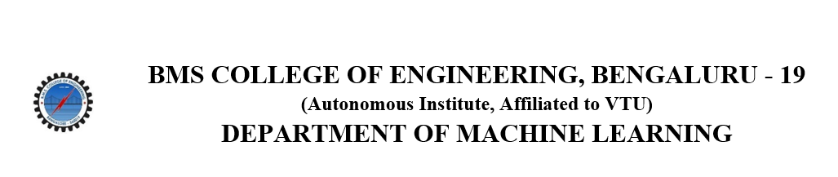
ACTIVITY REPORT
On

DUO’s DASH 2.0
- Name of the Club: BMSCE ACM STUDENT CHAPTER
- Name of the Activity: DUO’s DASH 2.0
- Objectives: As part of utsav24 BMSCE ACM Student Chapter had organized DUO’s DASH 2.0 which was a series of mini-games with a fun twist.
- Date, Time Venue of the Activity:
TOPIC | DUO’s DASH 2.0
DATE/DAY | Friday, May 17th 2024
VENUE | PJ Block 2nd floor open area.
- Name and details of collaborating agency (if it is collaborative/joint activity): Videsh Educon
- Brief summary of the Programme: Duo’s Dash, a unique event designed to test teamwork and interdependence, saw an enthusiastic participation of 100 individuals paired into dynamic duos. Conducted on the 2nd floor common area of the PJ block, the event featured four innovative mini-games that challenged participants to race against the clock while demonstrating their cooperative skills. The atmosphere was charged with excitement and anticipation as teams navigated through a blend of AI-driven and traditional game modes, vying for the title of the most reciprocal and dynamic duo.
The event kicked off with "Inverted Pictionary," where one teammate drew a word on an inverted laptop screen, and the other guessed the object. This game tested not only their artistic skills but also their ability to synchronize hand and brain movements under pressure. In "Movie Charades using AI," participants described movie scenes to an AI generator, which created images for their teammates to guess. This game highlighted the intersection of technology and creativity, pushing participants to think quickly and communicate effectively.
"Bomb Defuse" added a layer of tension, as duos had to verbally collaborate to defuse a virtual bomb in a Roblox game, with one holding the bomb and the other the manual. The intensity of this game required precise communication and trust, as any misstep could lead to a virtual explosion. Finally, "Snake and Ladder" combined elements of chance and skill, as rolling dice led participants to perform fun activities, earning points for their teams. Each activity required participants to think on their feet and adapt quickly, adding to the overall excitement of the event.
As the day concluded, Duo’s Dash celebrated the resilience and cooperation of its participants, with the undefeated pair against the clock emerging victorious. The event was praised for its innovative integration of AI and traditional gaming elements, providing a thrilling yet challenging experience. Participants shared their positive feedback, applauding the event's creativity and the seamless execution of the mini-games. Duo’s Dash not only fostered teamwork and patience but also showcased the potential of AI in enhancing interactive and engaging activities, making it a memorable event for all involved.
- Outcomes: Overall it was a fun and engaging game, an all-round experience involving thrill,team-work and skill
- Number of participants:
Number of Faculty | Number of  Non-Teaching Staff | Number of  External Participants | Number of Students
0 | 0 | 10 | 100

- Two or three relevant Photographs of the activity: (Geo-tagged photos are preferable)
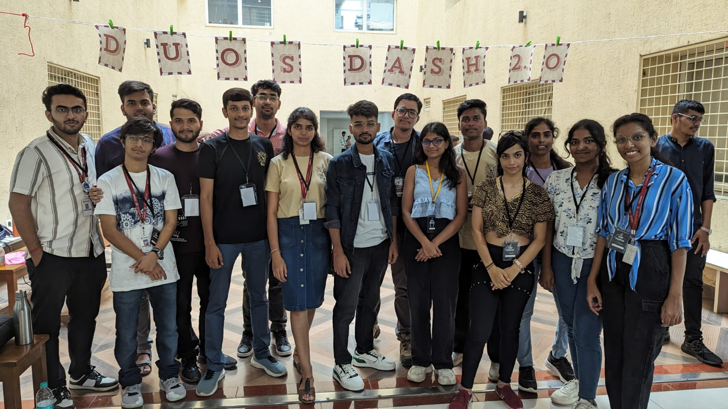

Supporting Documents
a) Attendance sheet
b) Circulars/Brochures
c) Certificates

